I want to put level and legend to the GIS item on the dash board like Sierra Leone. I tried but failed. Can you please help?
We are using DHIS2 version 2.13 build 12864
Dashboard GIS item – Sierra Leone:
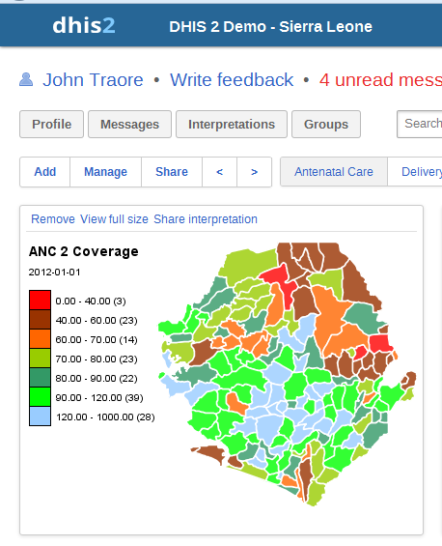
Dashboard GIS item – Bangladesh:
