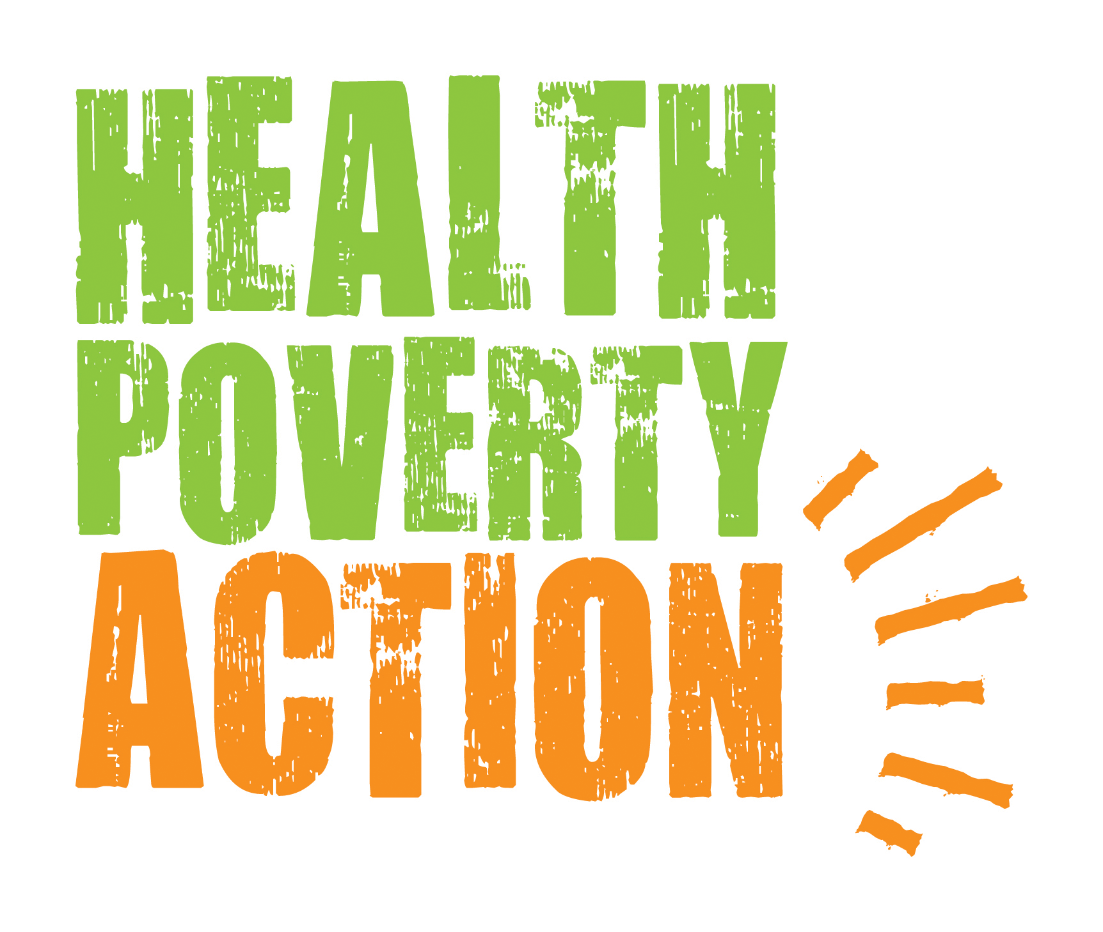


Terms of Reference for Consultancy Service
Phase 1: To Design an HPA Monitoring and Evaluation System on DHIS2

- BACKGROUND

  - Health Poverty Action (HPA)
HPA is a British international, development organization with a mission of supporting the poorest and most vulnerable people to achieve better health and wellbeing. HPA believes that health is a fundamental human right, and the provision of comprehensive primary health care is essential to its realization. HPA seeks to enable the poorest and most marginalized people, excluded from access to health services and information, to realize their right to health and to improve their health and wellbeing through training aimed at building local capacity to deliver sustainable health services and information. HPA gives priority to communities affected by conflict and political instability. HPA works with communities, health service providers and policy makers on long-term programs to develop appropriate and responsive primary health care services and to influence policy and practice at all levels. Established in 1984, HPA currently operates in 14 Countries worldwide, including Africa, Asia and Latin America. Many of our programs utilise community-based Primary Health Care (PHC) education & training, as well as mass-media health communication approaches, in collaboration with the local ministries of health and information, national NGOs/CBOs, and target communities themselves.
The distinctive approach of HPA can be summarised as a combination of three factors:
Emphasis on the need for justice rather than charity as HPA works to tackle not just the symptoms of poor health, but its root causes.
Priority given to those missed out by others in light of the fact that development initiatives exhibit a natural tendency to cluster together, and this leaves large populations with almost no support at all. They may be living in hard to reach areas, or difficult to support for some other reason.
Specialisation in providing a holistic approach, which is especially important for the poorest and most marginalised with little support. Tackling numerous factors together can bring lasting improvements – and also give rise to creative linkages and innovations.

Worldwide, HPA’s core health intervention are primarily in the following areas:
- Culturally appropriate maternal health services for minority groups
- Holistic approaches to sexual and reproductive health
- Working with Traditional Birth Attendants (TBA)
- Addressing traditional practices that are harmful to health
- Behaviour change communication (BCC)
- Supporting women, men and youth to access their health rights
- Communicable diseases, such as HIV, malaria and TB
- Addressing the underlying causes of poor health
- Violence against women
- Advocacy and engagement with decision makers

These programmatic lines are realized through implementation plans and operational arrangements which reflect Country specific legal frameworks, local needs and customs. However, although similarities are often found particularly among programmes within the same region, HPA has successfully implemented multi-country projects across the three continents where it operates.

  - Importance of Monitoring and Evaluation
Monitoring and evaluation are integral parts of the project cycle to ensure the proper and timely implementation of planned project activities. While monitoring deals with tracking progress with the continuous day-to-day implementation the project activities, evaluation regards the more systematic process of establishing the extent to which a project has achieved its results and objective.

A good M&E system in place helps provide program stakeholders with critical information on program implementation progress, which in turn enables the program implementer to make decisions on program inputs, activities and strategies for continued program improvement; to draw organizational learning and promising practices with potential for scale-up and consideration in future designs; provide the evidence for accountability and transparency of resource use; and to inform and influence policy makers and donors through analysis of outcomes and impact of the action.

A well-established M&E systems hence provides regular feedback on project progress indicating problems for timely corrective actions; track and evidence progress of the project towards targets through milestones along the course of project implementation; enhance transparency, accountability and stakeholder ownership of the project; and produce evidence for project effectiveness to influence policy.

  - Current Monitoring and Evaluation approach in HPA Programmes
The current monitoring and evaluation system has moved from the individual projects M&E approach to a global programme approach which compares and analyses information gathered in different countries and programmes using an Access Database. This is the result of the development of standard data collection templates and databases as well as a more comprehensive and consistent approach to M&E, which was initially piloted in HPA Country Offices in Africa.

Following the pilot in Africa, the piloted M&E system was reviewed and upgraded through an analysis of its functioning and the inclusion of elements specific to Asia and Latin America where the system has not been rolled out yet. The review looked at the key M&E tools, and particularly the M&E plan template, in light of the experience gathered about their functioning in Africa; reviewed and provided feedback on the use of the M&E database in one selected HPA Country Office; incorporated 10 new key indicators into the global database after consultations with Asia and Latin America Country Offices; designed data collection tools for the new indicators and developed a guide for field staff to support them in compiling and use the data collection tools. Asia and Latin America Country Offices are not yet rolling out the M&E system on Access Database but this is planned shortly.

Currently the Country Offices generally use paper forms to collect data, and input data at a country level either in the field office or in the national office. Most of these offices have Internet access, however due to the large size of the files and slow Internet connection, some of them send files within offices nationally by email or DropBox, others transfer them between national offices using a USB stick. The country database is then sent to HPA London office occasionally by email or Dropbox. Due to the short time that data has been collected across a small number of countries, HPA London is not yet aggregating the data globally.

  - Moving to a DHIS2 based system
HPA would now like to move its M&E system to be cloud-based and allow Country Offices to input data directly without sending this to HPA London office for aggregation. After considering different technological solutions, HPA identified DHIS2 as the best solution for HPA projects. DHIS2 is a flexible, web-based open-source information system with data visualization features including GIS showing data on maps, charts and pivot tables. DHIS2 is typically used for government national health information systems for data management and analysis purposes, for health programme monitoring and evaluation, for facility registries and service availability mapping, for logistics management and for mobile tracking of pregnant mothers in rural communities.

Two feasibility workshops were held in Yangon and Hanoi with key management staff from Burma and Cambodia to discuss the feasibility of implementing DHIS2 with HPA, which found that the system would fit HPA needs in those countries. Discussions have been already started with University of Oslo, Bao System hosting company (which is the only company that currently hosts DHIS2) and other organisations implementing the system.

HPA is seeking to pilot DHIS2 in Cambodia and Burma in 2015 with a view of scaling up the pilot in 2016. In the long term, we are looking to put DHIS2 in place in our 14 Country Programmes where we have a range of maternal and newborn child health, TB, Malaria and HIV programmes in remote, hard to reach areas. We are planning to implement it first in South East Asia (Myanmar, Cambodia, Laos, Vietnam and China) then in Africa (Somalia, Ethiopia, Kenya, Sierra Leone, Namibia and Rwanda) and finally in Central America (Guatemala, Nicaragua, Honduras and El Salvador).

We are now looking to contract an expert consultant in DHIS2 to conduct Phase 1 of this pilot – setting up the system and developing the training manual. This will involve a requirements analysis and validation, and implementation plan including setting up data elements, data entry forms, validation rules, indicators and reports in order to create a fully-fledged system for data management.

  - Considerations for DHIS in HPA
- Our staff who will be collecting the data come from varying backgrounds, levels of education, understanding of M&E, technology abilities, and speak different languages
- Our data is mostly gathered through secondary data at health facilities, surveys, and client exit interviews
- Most of our data is aggregated, however in some cases (EPI, nutrition, communicable diseases) is client based.
- Some of our data is relational, for example mothers and their children – and the health information of these mothers and children, allowing continuum of care to be reflected, - as well as other parameters like GIS and mobile phone number
- A medium to high level of security is required for our system, particularly client based information. A VPM tunneling system to encrypt information could be one option for consideration
- We have varying levels and speed of Internet access in our different offices and data collection locations, some without Internet access for days at a time, some offices without Internet connection ever. A system whereby data entry can be done offline and later update when Internet is recovered (without losing data if the browser is closed) would be ideal
- We have mobile phone coverage in all offices but not all data collection sites
- HPA is interested in a mobile application implementation with DHIS. HPA is willing and able to invest in adequate tablets, Android phones, regular phones to send data via SMS, and Android simulator machines for computers to support areas with Internet issues
- A system whereby data is synched value by value when online to allow real time analytics would be preferable rather than manually refreshing the data warehouse

- SuggeSTed METHODOLOGY

The proposed task of designing a DHIS2 system for HPA will require an evaluation of the existing M&E system and an analysis of programmes and systems in HPA’s Country Offices and London headquarters. The consultant is encouraged to consider the following minimum steps in the framework of his/her proposed methodology and is requested to add as many others as it is felt necessary for this undertaking:

- Analysis of data requirement: through desk review and interviews with various staff members, gain a full understanding of the needs of the organisation for data collection, analysis, and sharing / reporting.
- Feasibility analysis of use of different types of technology: through desk review and interviews with various staff members, come to an understanding of the technologies used by HPA at different levels, constraints, and options that could work in different contexts.
- System design and architecture: based on the above, develop 1) a system for HPA Cambodia and Burma programmes to put in place DHIS2 and 2) in detail, propose the exact steps and timeline for the pilot of DHIS2 in Cambodia and Burma.
- System configuration: set up data elements, data entry forms, validation rules, indicators and reports in order to create a full-fledged system for data management.
- Training tools development: provide training materials for Country Offices to roll out the systems at field level.

- SPECIFIC TASKS TO BE DONE BY THE CONSULTANT

The consultant under this engagement will be expected to undertake the following major undertakings:
- Develop an inception report that clearly defines the methodologies for information gathering, analysis, consultation/presentation and report writing with regards to this consultancy. HPA will approve proposed methodologies, procedures and instruments;
- Collect and analyse the relevant information to review and upgrade the current M&E system to a DHIS2 one including analysis of stakeholders;
- Draft and share the revised templates and tools specified in the above sections;
- Undertake consultations with key HPA staff for inputs and approvals;
- Produce a final analysis report, forms and electronic database system incorporating feedbacks from stakeholders;
- Provide training materials for Country Offices to roll out DHIS2.

- Deliverables

- A detailed protocol to undertake the task
- A DHIS2 design
- Revised templates and tools
- A draft/final templates, and tools
- Training materials to roll out the system in country
- Final report of the whole consultancy undertaken

- Proposed Time table

- The assignment should start in August 2015 and be finalised by September 2015.
- Tentative schedule will be jointly agreed after the assignment is confirmed.

- location of work

The task might require travel to Cambodia and Burma for training, this will be discussed during the tentative schedule design and cost involved for travel will be covered by HPA and should not be included in the initial quotation. The assignment involves extensive consultation with concerned Country Directors, Programme Managers and London based Heads of Programmes and Programme Officers.
- MINIMUM CRITERIA FOR SUBMISSION OF PROPOSAL

The consultant is expected to demonstrate that he/she has a track record of no less than 2 years executing similar undertakings specifically related to DHIS2.

The consultant is expected to have high level of experience in designing and implementing programme monitoring and evaluation systems, with practical experience in health and health related programme monitoring and evaluation.

High competency in DHIS2 is a mandatory requirement.

- PREPARATION AND SUBMISSION OF THE PROPOSAL

While preparing the technical proposal, applying consultants must give attention to the following:
- Consultant’s CV /details of qualifications and experience (no page limit).
- The technical proposal (no longer than 6 pages) should provide an outline of the consultant’s recent experience on similar undertakings.

While preparing the financial proposal (no longer than 1 page), applying consultants should provide consultancy fees in daily rates in pound sterling (GBP).

Bidders applying for the Phase 1 consultancy are also encouraged to submit a separate application for the Phase 2 consultancy.

Bids should be submitted no later than midnight BST July 15, 2015 to personnel@healthpovertyaction.org The contact person for this consultancy is Nicole Tobin (n.tobin@healthpovertyaction.org).

- Logistics

HPA will not provide vehicle, office space, computer, copying and printing services, telephone service or facilities for workshops, and the cost of compulsory security escorts throughout field travel days. It is hence advisable to include all these costs within prices to be quoted by applicants.

- Reporting requirements
The consultant is expected to update progress with the task to the HPA Head of Programmes Asia & Latin America and the Programme Development and Quality Advisor.

- Others

All relevant documents should be submitted to HPA upon completion of tasks both in hard and soft versions.

- Payment

The payment for the consultancy work shall be made in two phases, according to the following schedule:
- The first payment of 40% advance of the total agreed contractual amount of Phase 1 will be made immediately after the signing of the contract agreement.
- The remaining payment of 60% of the total contractual amount of the Phase 1 shall be made to the consultant upon approval and acceptance of the work carried out by the consultant, consisting of the above tasks and deliverables.

