The report which calculates completeness based on the presence of obligatory data elements is increasingly important for us in the DRC. We are proposing to rely heavily on this measure as an indicator for the success of implementation.
Currently, the report works fine when calculated on a monthly basis – see screen shot.

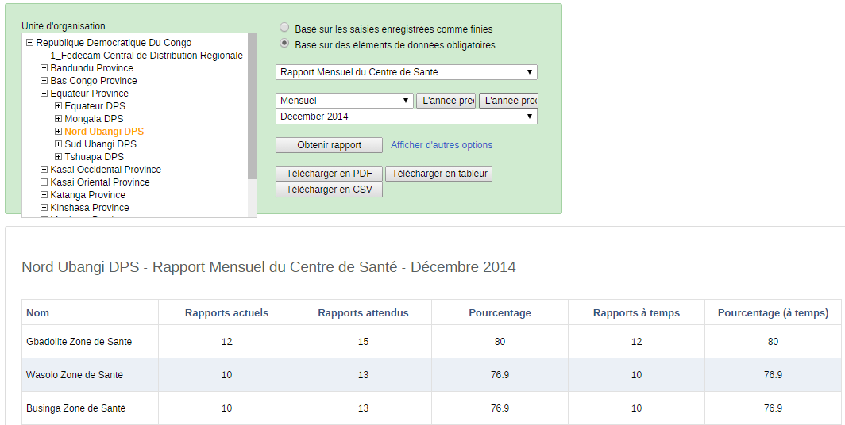

However, when I try to calculate the same report for a period of three months, it again calculates the composite which is problematic. The total number of health centers with obligatory data for the quarter is 2 (!) which is down from 12 for the month of December.
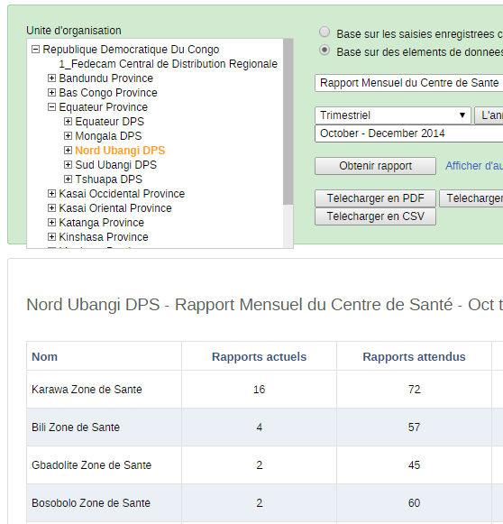

The current formula is:
- Health facilities with obligatory data elements for October AND November AND December

We request the formula be:
- Health facilities with obligatory data elements for October OR November OR December

